Assignment 1

Question a

ROC CURVE

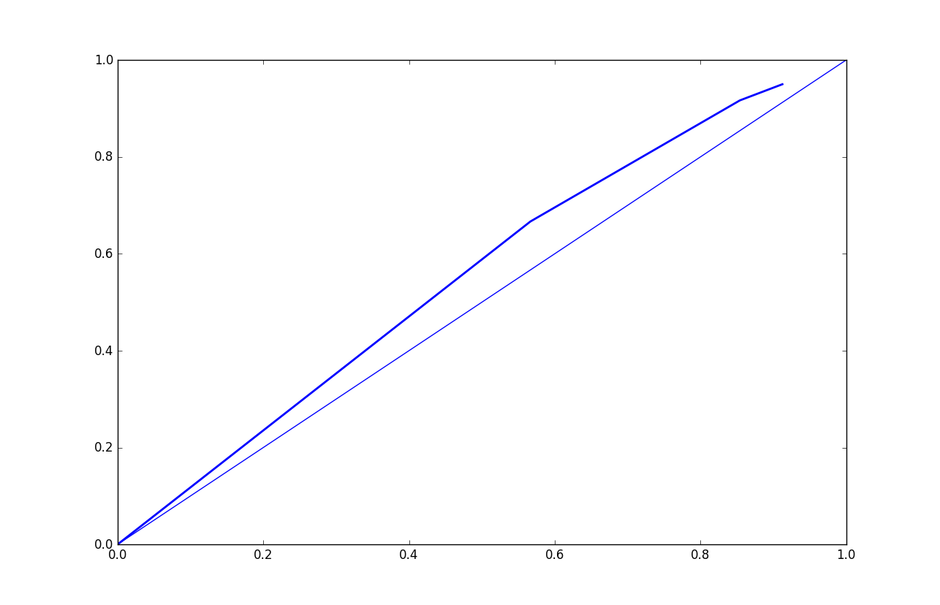

Question c
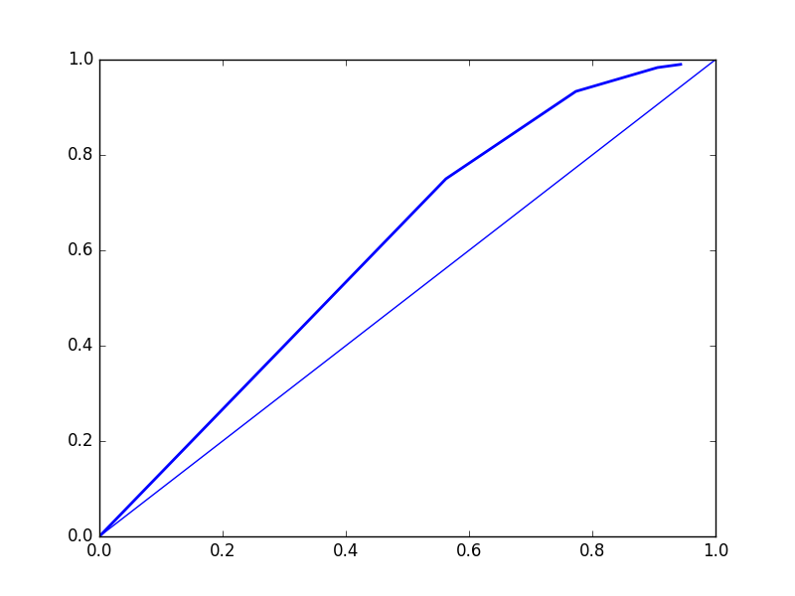

Question D

Naive basyes algoritom is simple and can work with a smal l date set as we did wirh Regression

Apply 4

